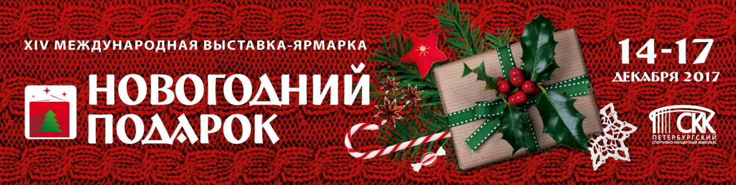

The biggest Christmas Fair in Russia- the New Year’s Gift Exhibition, was held from 15 till 18 December 2016 in St. Petersburg Sport and Concert Complex. It was very interesting event in the lead of Christmas’ holidays.
Organizer- exhibition company Farexpo, so-organizer- Solnce company.
There were presented over 750 companies from 18 countries. Exhibitors presented a wide variety of goods to prepare for holidays. People could find many booths with clothes and accessories, cosmetics and goods for their homes. Visitors enjoyed with hand-made presents, hi-tech goods and of course decorations for Christmas trees. Big and colorful toys, garlands and other decorations created the friendly atmosphere and help to feel the spirit of Christmas!
Visitors could buy delicates from fish and meet for festive table. Also they could choose some sweets, natural farmer products and many others.
One of traditions at the Fair is a charity. This year there were over 10 charity organizations. There were different exclusive souvenirs, which were made by members of this organizations and by local people as well. All money which those organizations have got, they will spend for present for orphans children and people with disabilities.
New Year’s Gift Exhibition is a holiday for the whole family. There were different workshops, where everybody could make a Christmas crafts. For the youngest guests there worked a kindergarten. Closer to the stage people could meet reindeers and little ponies. Animals were very friendly and liked to meet with all guests.
Also there were a mobile photo studio. Citizens could make very nice pictures with winter interior. Make up artists and professional photografers were ready to help all guests. At the main stage there were entertainment program during all four days.
Annual photo-contest “Magic pumpkin” were ended by rewarding ceremony at the stage. The main prize- electric grill went to Elena Suragina for the first place. The second place took Ekaterina Alexandrova, the third- Joseph Furman. Small prizes got all participants of the photo-contest.
The New Year’s Gift exhibition was visited by 58 753 people in 2016. Additional information is available on our web-site expogift.ru.

If you are interested in additional advertising materials please contact:
Elena Vinogradova (PR-manager): +7 (812) 777-04-07 ad. 614; e-mail: public@farexpo.ru
Margarita Makarkina (marketing manager) +7 (812) 777-04-07 ad. 657; e-mail: reklama2@farexpo.ru

